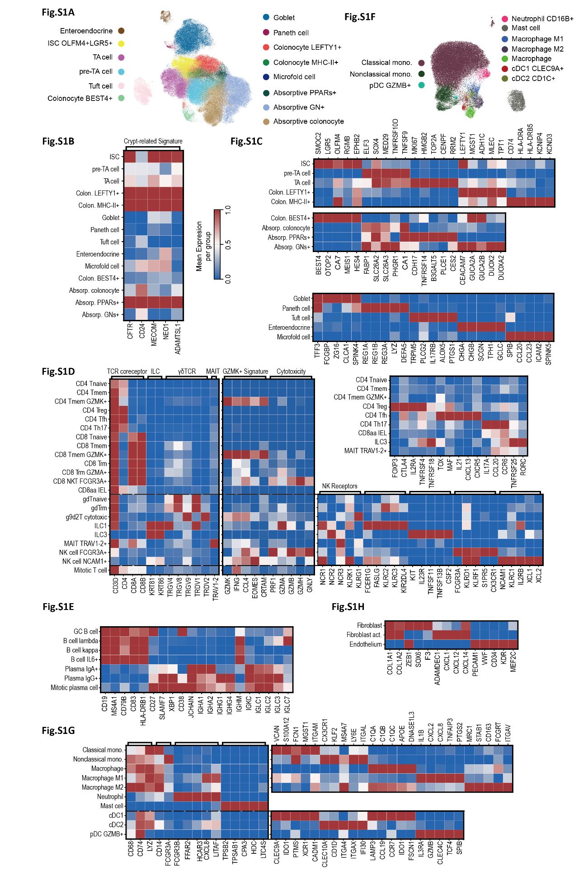
Figure S1. The immune and stromal landscape of the mucosal microenvironment in chronic intestinal inflammation.
(A) UMAP visualization of colonic epithelial cell subsets. Dimensionality reduction using the UMAP algorithm illustrating the clustering of colonic epithelial cells, with distinct colors representing functional subpopulations within the epithelial lineage. (B, C) Heatmaps of signature genes for colonic epithelial lineages. Panel (B) highlights gene sets specific to colonic crypt-associated subsets. Panel (C) displays markers for the three major epithelial lineages: stem/progenitor cells (top), absorptive lineage (middle), and secretory lineage (bottom). All values are row-normalized. (D) Expression profiles of marker genes for T cells and innate lymphoid cells (ILCs). Color intensity represents row-normalized average expression. The left panel shows lineage-defining markers (e.g., TCRs and co-receptors); the middle panel highlights the divergent expression patterns of GZMK relative to classic cytotoxic genes; the right panels display markers for innate and adaptive immune subsets, respectively. All values are row-normalized. (E) Characterization of B cell and plasma cell subsets. Heatmap showing signature genes associated with the developmental stages and functional states from B cells to plasma cells. All values are row-normalized. (F) UMAP visualization of the myeloid lineage. Clustering and distribution of all identified myeloid cell subsets in UMAP space. (G) Myeloid cell subpopulations and their signature genes. (Left) Core markers for major myeloid lineages. (Top right) Feature genes for the monocyte-macrophage system. (Bottom right) Discriminative markers for dendritic cell (DC) subsets. All values are row-normalized. (H) Heatmap of stromal cell signature genes. Expression patterns of canonical markers defining stromal components, including fibroblasts, endothelial cells, and other mesenchymal cells. All values are row-normalized.
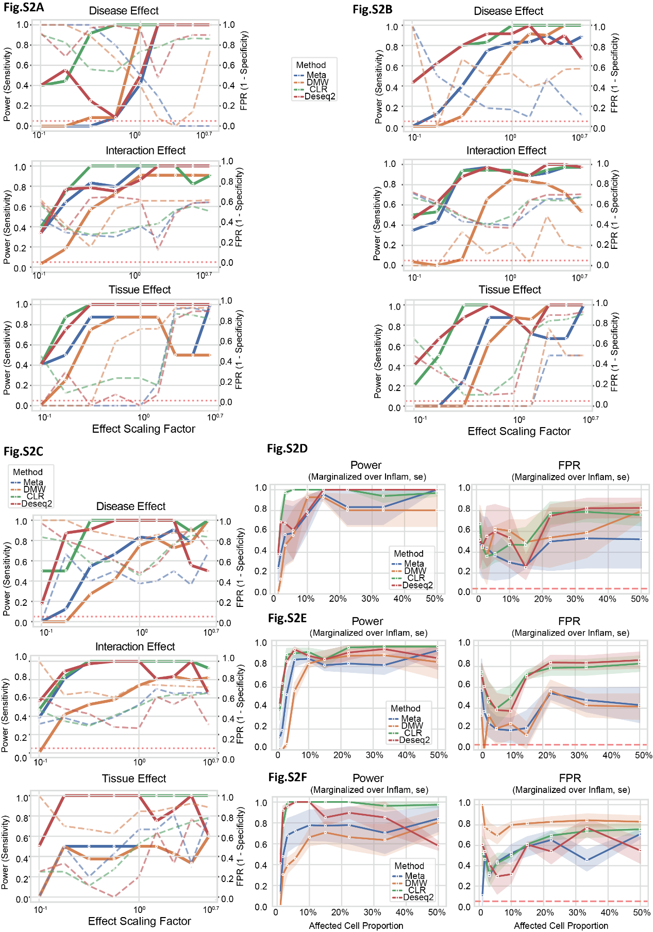
Figure S2. Systematic benchmarking of differential abundance analysis methods across multiple simulated scenarios.
(A–C) Performance evaluation of statistical methods under various data distribution models. Line plots evaluating the performance of the RCE framework (denoted as Meta) and its three constituent methods (DMW, CLR, and DESeq2). Simulations were generated using three probabilistic models: Dirichlet-Multinomial (DM, A), Logistic-Normal Multinomial (LNM, B), and CLR-based resampling from empirical observations (Resample, C). Solid lines represent statistical power, while dashed lines indicate the False Positive Rate (FPR). The x-axis denotes the effect size scaling factor. Panels in each column correspond to tests for Disease Effect (top), Interaction Effect (middle), and Tissue Effect (bottom). (D–F) Impact of disease-associated cell proportion shifts on model detection performance. Line plots showing the Power and FPR of DMW, CLR, DESeq2, and RCE (Meta) as the preset proportion of affected cells increases from 10% to 50%. Simulated datasets were constructed using DM (D), LN (E), and CR (F) models. Shaded areas around the lines represent the 95% confidence intervals (95% CI) derived from multiple iterations, reflecting the robustness of the models under varying compositional perturbations.
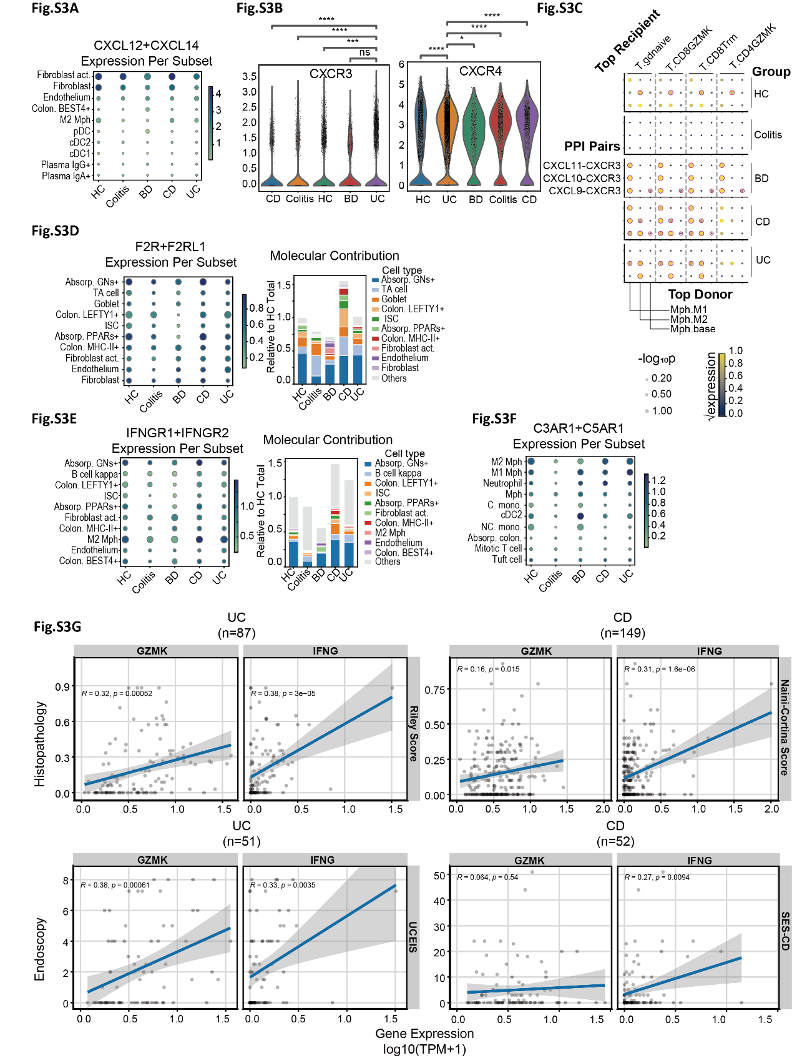
Figure S3. Molecular signatures, microenvironmental interaction potential, and clonal diversity of GZMK⁺ T cells.
(A) Expression profile of IFNG. Dot plot indicating the percentage of expressing cells and average expression levels across subsets. (B) Expression profiles of chemokine receptors CXCR3 and CXCR4 in the GZMK⁺ subpopulation. Violin plots show the expression levels of CXCR3 (left) and CXCR4 (right) grouped by disease state, arranged in ascending order of mean expression. Statistical significance was determined using the Mann-Whitney U test (*: p < 0.05; **: p < 0.01; ***: p < 0.001; ****: p < 0.0001). (C) Intercellular communication via the CXCR3 axis predicted by CellPhoneDB. Bubble plot illustrating the interactions between CXCR3 and its ligands CXCL9/10/11 (dot size: -log10(p-value); color: normalized average expression level; red circles indicate significant interactions with p < 0.05). (D–E) Source analysis of downstream target genes for GZMK⁺ cells. (D) Combined expression of F2R and F2RL1; (E) combined expression of IFNGR1 and IFNGR2. (Left) Dot plots quantifying gene expression across myeloid subsets, where dot size represents the percentage of expressing cells and color intensity indicates the average expression level. (Right) Stacked bar charts depicting the relative contribution of different cell origins to the total tissue-wide expression pool, normalized by the total molecular abundance in healthy samples. Cell subsets are ranked in descending order based on their weighted total expression across five conditions. (F) Expression profile of C3AR1 and C5AR1. Dot plot indicating the percentage of expressing cells and average expression levels across subsets. (G) Correlation analysis of GZMK and IFNG expression with clinical indices. Validation using bulk RNA-seq data from the IBDome database, examining the correlation between GZMK (left) or IFNG (right) levels and histological (Riley score) or endoscopic (UCEIS) severity in UC patients, as well as histological (Naini-Cortina score) or endoscopic (SES-CD) severity in CD patients. Statistical significance was determined using the Pearson correlation test.
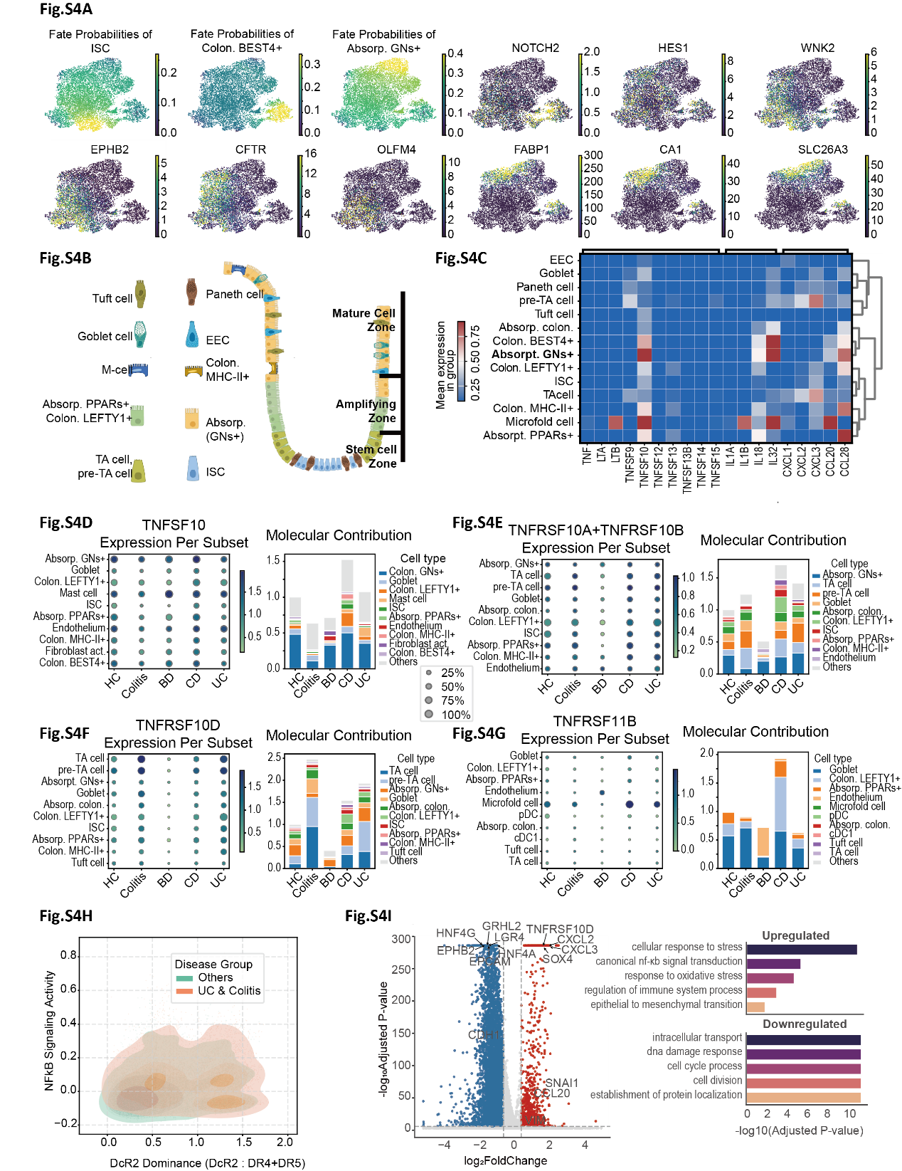
Figure S4. Epithelial lineage organization and exploratory TRAIL-related signaling in GNs⁺ colonocytes.
(A) Three major developmental fates within the colonic absorptive lineage. UMAP plots illustrate fate probabilities from intestinal stem cells (ISCs) to the mature absorptive lineage, alongside established genes associated with spatial localization: the crypt base (EPHB2, CFTR, OLFM4); the lower-to-mid crypt transition zone (NOTCH2, HES1, WNK2); and the crypt surface/top epithelium (FABP1, CA1, SLC26A3). (B) Schematic representation of colonic crypt epithelial subpopulations. Based on differentiation trajectories and PAGA analysis, we reconstructed the spatial organization of ten major epithelial subsets within the colonic crypt, revealing a distinct spatial segregation from the basal stem cell compartment to the apical maturation zone. (C) Expression heatmap of major cytokines and chemokines across all epithelial lineages. Data are presented without row normalization to demonstrate the absolute expression levels of TNFSF10 specifically within the GNs⁺ subpopulation. (D-G) Cell-of-origin analysis for TRAIL and its receptor family. Expression profiles of (D) TNFSF10 (TRAIL); (E) TNFRSF10A/B (DR4/DR5); (F) TNFRSF10D (DcR2); and (G) TNFRSF11B (OPG). (Left) Dot plots quantifying gene expression across myeloid subsets, where dot size represents the percentage of expressing cells and color intensity indicates the average expression level. (Right) Stacked bar charts depicting the relative contribution of different cell origins to the total expression pool in tissues, normalized by the total molecular abundance in healthy samples. Cell subsets are ranked in descending order based on their weighted total expression across five conditions. (H) Impact of the DcR2 to DR4/DR5 ratio on NF-κ B pathway activation. Kernel Density Estimation (KDE) scatter plots showing the correlation between the DcR2/DRs ratio (x-axis) and NF-κ B pathway scores (y-axis). A rightward-upward shift in Colitis/UC-derived epithelial cells indicates that high DcR2 levels are closely linked to aberrant NF-κ B activation. (I) Differential gene expression (DGE) of crypt-bottom undifferentiated subpopulations across disease origins. The analyzed populations include ISCs, TA cells, pre-TA cells, antigen-presenting colonocyte (MHC-II⁺), and regenerative colonocytes (LEFTY1⁺). To ensure statistical robustness and comparability, each subpopulation was downsampled to achieve consistent cell numbers across each group. (Left) Volcano plot showing differentially expressed genes between UC and non-inflamed samples (p < 0.01, |logFC| > 0.5). (Right) Bar chart showing significantly enriched GO terms for upregulated and downregulated genes.
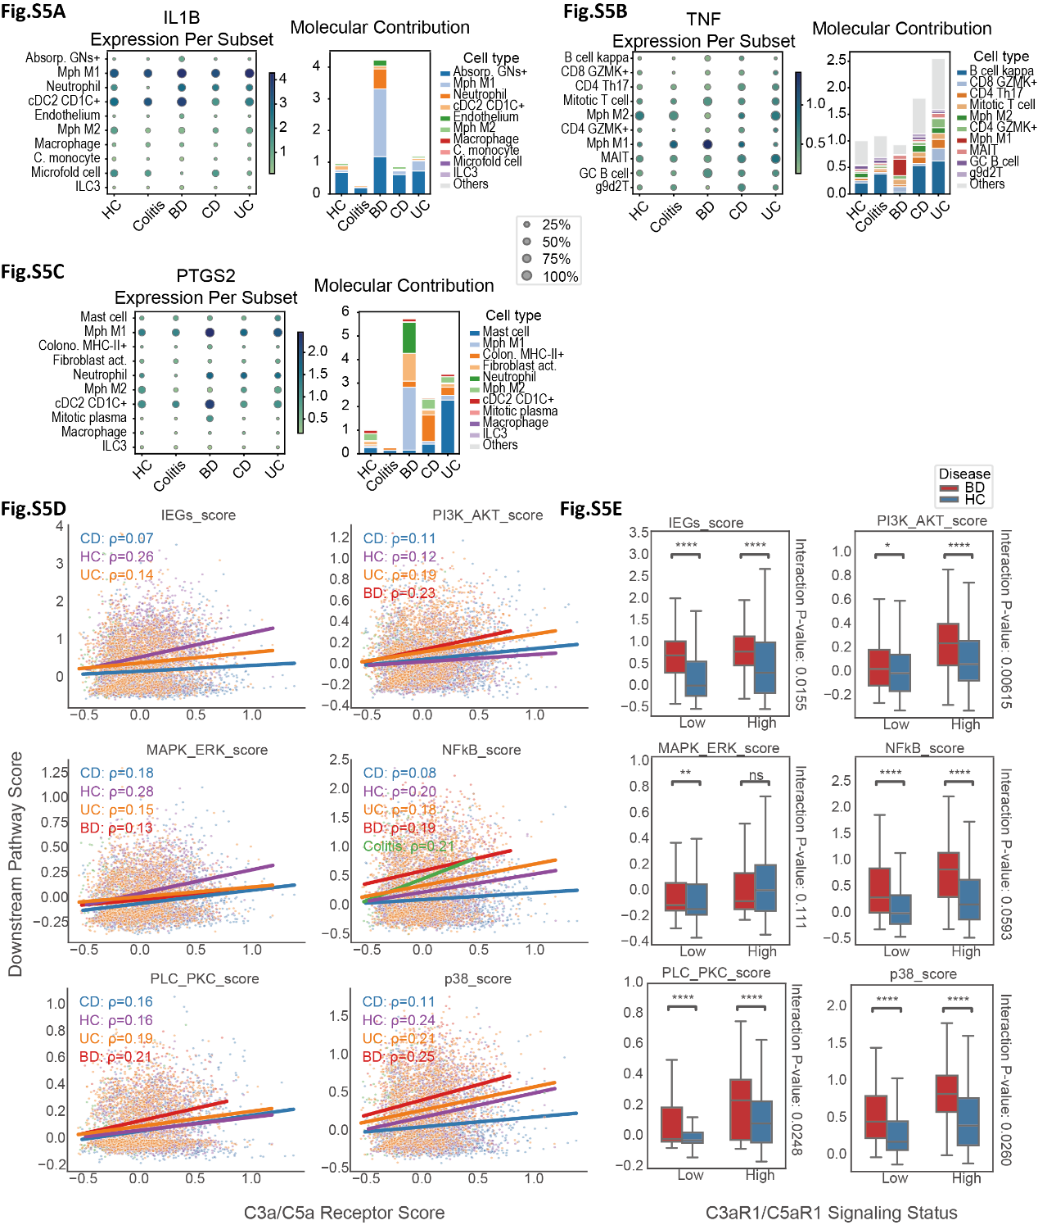
Figure S5. Myeloid inflammatory output and complement receptor-associated signaling features in Behçet’s disease.
(A-C) Cellular sources of pro-inflammatory factors TNF, IL1B, and PTGS2 in myeloid cells. Expression profiles of TNF (D), IL1B (E), and PTGS2 (F). (Left) Dot plot indicating the percentage of expressing cells and average expression levels across subsets. (Right) Stacked bar chart depicting the contribution of cell origins to the total expression pool, normalized to healthy controls. (D, E) | Association between C3A/C5A signaling and downstream pathways in myeloid inflammatory cells. (D) Scatter plots illustrating the correlation between complement signaling scores (x-axis) and downstream pathway scores (y-axis) across disease-derived myeloid subsets (macrophages, DCs, and neutrophils). Spearman’s rank correlation coefficients are indicated, with trendlines fitted by OLS regression. (E) Comparison of activation scores for six downstream pathways across cell origins and stratified complement signaling levels (top vs. bottom 20%). Statistical significance was determined by Mann-Whitney U test.

